The WOW! Case

From

Toiletry Case Corporation

**User Manual**

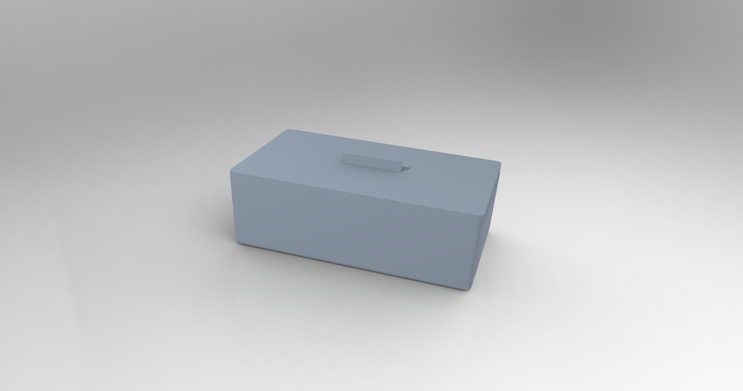

PLEASE READ THE FOLLOWING MANUAL BEFORE OPERATING THE TOILETRIES CASE 2.0

**Toiletries Case Corporation’s WOW! Case**

**Table of Contents**

Assembly...........................................................3

Use....................................................................4

Maintenance.....................................................5

Warranty Information.......................................6

Service Center...................................................7

**Assembly**

**-Our WOW! Case is designed to be convenient every step of the way, and assembly is no exception! We have designed the WOW! Case with a simple 3-piece construction, making assembly and maintenance as easy as possible for you!**

**-Packaging includes: 1 WOW! Case, 1 WOW! Lid, 4 replacement rubber rings**

**-Assembly instructions: When you receive your WOW! Case, it will be pre-assembled with a rubber ring. However, it is recommended that you clean the case prior to use and allow all components to air dry as instructed.**

**-Replacement rubber rings: Even with perfect maintenance, the rubber sealing ring may eventually deteriorate, or allow mold to begin forming. This is not the end of the world, as we have included 4 replacement rubber rings. Simply remove the old ring from the groove in the lid, wash the lid and allow it to dry, and then stretch the new ring into the groove. Good as new!**

**Use**

**- Travel with Ease and Style:**

**Say goodbye to the days of stuffing your toiletries in plastic bags or settling for bulky, disorganized pouches. Our WOW! Case is designed with the modern traveler in mind, providing a compact and stylish solution for your grooming essentials. Coming in several monotone styles, our toiletry case gives a modern touch to the rest of your environment!**

**- Smart Compartmentalization for Ultimate Organization:**

**Never again will you have to fumble through your suitcase searching for a misplaced toothbrush or shampoo. Our toiletry case features intelligently designed compartments tailored to fit everything you need. From toothbrushes and toothpaste to travel-sized shampoo and soap, every item has its designated space, ensuring a clutter-free and stress-free travel experience, including a toothbrush stand in the bottom right corner.**

**- Secure and Durable:**

**Constructed with high-quality ABS plastic, our WOW! Case is not only stylish but also built to last. The sturdy rubber lining ensures that your toiletries stay secure during travel, providing you with peace of mind and allowing you to focus on your adventures without worrying about spills or leaks.**

**- Versatility at its Finest:**

**Whether you're a frequent flyer, a weekend explorer, or an on-the-go professional, the WOW! Case is your perfect companion. Compact enough to fit in your carry-on or backpack, yet spacious enough to accommodate all your essentials, it's the ideal travel accessory for every occasion that comes in a 7 x 4 x 2 size.**

**- The Perfect Gift for Travel Enthusiasts:**

**Searching for the ideal gift for a friend, family member, or colleague who loves to explore the world? Look no further! Our WOW! Case is a thoughtful and practical gift that will be appreciated by any globetrotter and do exactly what it must- WOW your loved ones!**

**Maintenance**

1. Empty and Clean the Case Regularly:

Begin by emptying the contents of your WOW! Case and inspecting each compartment. Remove any remnants of toiletries, such as toothpaste residue or soap scum. Use a mild soap solution and a soft cloth to clean the interior and exterior of the case, ensuring it remains free from bacteria and odors. Removed and wash the rubber liner, and allow all components to air dry before reassembly

1. Organize Items by Size and Use:

Efficiently organize your toiletries by categorizing them based on size and usage frequency. Group items like toothbrushes, toothpaste, and floss together in one compartment, while placing soap, shampoo, and other liquid items in spill-proof containers in a separate section. This method ensures easy access and minimizes the risk of leaks.

1. Utilize Travel-sized Containers:

To maximize space and maintain the portability of your toiletry case, invest in travel-sized containers for liquids. Transferring your favorite shampoo or face wash into smaller, leak-proof bottles not only saves space but also prevents potential spills that could damage the contents of the case.

1. Secure the Lid with Rubber Lining:

Pay attention to the lid of your WOW! Case, specifically its rubber lining. Ensure that the rubber seal is intact and free from cracks, wear, or mold. This lining plays a crucial role in keeping your toiletries secure. Replace the rubber lining if you notice any signs of deterioration.

1. Regularly Update and Rotate Contents:

Periodically assess your toiletry needs and update the contents of your case accordingly. Replace expired items, refill containers, and adapt your travel essentials to the duration and type of trip you're embarking on. This practice ensures that your toiletry case is always ready for your next adventure.

By following these maintenance tips provided by TC Corp Help Team, you'll not only keep your precious WOW! Case in optimal condition but also ensure that your travel essentials are organized, accessible, and protected. This commitment to upkeep will make your travel experiences more enjoyable, with the confidence that your hygiene essentials are well-maintained and ready for any journey.

**Warranty Information**

The WOW! Case is backed with a 60-day warranty, which will ensure a full refund. Whether you are not satisfied with the product or simply had a change of mind, TC Corp is more than happy to give your money back. Find more information on contacting us about your WOW! Case on the “Contact Us” page on our website.

TC Corp is not responsible for any potential breaking and/or disruption of a product when physically purchased through any retail store. However, if the product that is ordered online is damaged, TC Corp will send a new WOW! Case for free within two (2) weeks of report.

Service Center

The WOW! Case from Toiletries Case Corporation is correct and up to date as of 2023. To remain updated on any future news about our company’s product, refer to the team’s website, email addresses, phone numbers, and mailing address.

Website:

<https://webpages.charlotte.edu/rlopezge/Component_File.html>

Phone Number:

704-WOW-CASE

Address:

9201 University City Blvd., Charlotte, NC 28223

Contact The Team

Vicky Hajinian – [vhajinia@uncc.edu](mailto:vhajinia@uncc.edu)

Renee Kaluzny – [rkaluzny@uncc.edu](mailto:rkaluzny@uncc.edu)

Andrew Jordan – [ajorda68@uncc.edu](mailto:ajorda68@uncc.edu)

Rafael Lopez Geronimo – [rlopezg@uncc.edu](mailto:rlopezg@uncc.edu)